**CENG 315 - INFORMATION MANAGEMENT PROJECT**

**RESTAURANT MANAGEMENT SYSTEM**

**Entity Sets:**

**Manager**

-manager_id

-manager_first_name

-manager_middle_name

-manager_last_name

-phone_number

-hiredate

-salary

-annual_holiday

**Chef**

-chef_id,

-chef_first_name

-chef_middle_name

-chef_last_name

-profession

-ranking

-phone_number

-shift

-hiredate

-salary

-annual_holiday

**Cashier**

-cashier_id

-cashier_first_name

-cashier_middle_name

-cashier_last_name

-cash_no

-phone_number

-shift

-hiredate

-salary

-annual_holiday

**Bill**

-bill_id,

-bill_price

-tip_amt

-bill_date

**Waiter**

-waiter_id

-waiter_first_name

-waiter_middle_name

-waiter_last_name

-phone_number

-shift

-hiredate

-salary

**Courier**

-courier_id

-courier_first_name

-courier_middle_name

-courier_last_name

-phone_number

-shift

-hiredate

-salary

**Order**

-order_id

-order_date

-order_time

-order_status

-order_type

**Customer**

-customer_id,

-customer_first_name

-customer_middle_name

-customer_last_name

-customer_phone_number

-customer_address

**Order Item**

-item_name

-item_price,

-item_quantity

-item_type

-item_description

-special_option

-calories

**Table**

-table_no

-capacity

-status

-place

**Food Supplier**

-supplier_id

-supplier_name

-product_type

-contact_info

-supply_type

**Relationship Sets:**

Employs: It is used for employing cashiers, chefs, couriers and waiters to the restaurant.

Paid To Cashier: The bill of a table’s order is paid to cashier.

Paid To Courier: The bill of a customer’s order is paid to courier.

Gives: It describes that the table gives orders.

Prepared By: Orders are prepared by chefs.

Contains: Each order contains order items.

Serviced : Orders which are prepared are serviced by a waiter.

Delivers: If order is a take-out order, then courier delivers the order to a customer.

Trades: Managers trade with food suppliers in order to bring food product.

Has: Each order has one bill.

Reservation: A customer can reserve many tables and a table can be reserved by one customer at a specific time.

**Users Of The System**

Managers

Chefs

Waiters

Cashiers

Couriers

Customers

**ER Diagram**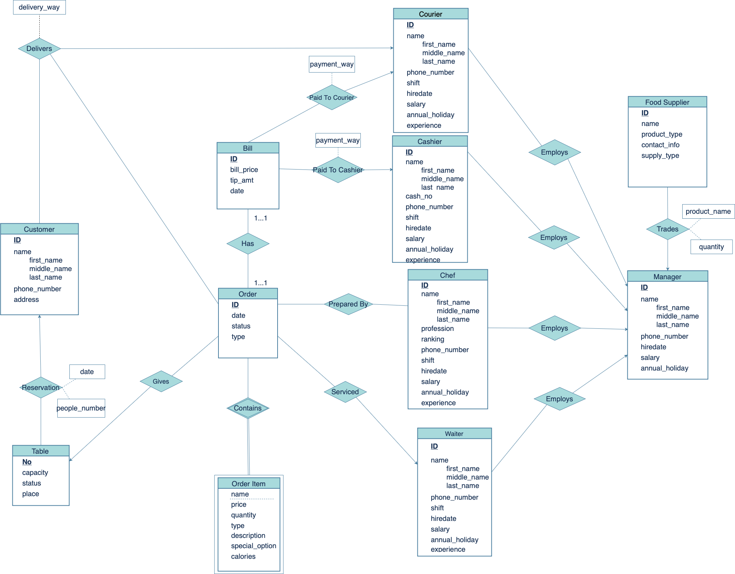

**Business Rules**

In Customer table, existence of ID, first name, last name and phone number information is necessary. If a customer wants to take-home order, then he/she should give his/her address information as well.

Reservation table should contain customer_id, table_no, date and time fields with non-null values.

If a reserved table gives an order, then the order date cannot be prior to reservation date.

If there is an order, there should be at least one order item which belongs to the order.

**Assumptions**

**Reduction To Relational Schema**

Customer(customer_id, customer_first_name, customer_middle_name, customer_last_name, phone_number, address)

Reservation(table_no, customer_id, date, people_number)

Table(table_no, capacity, status, place)

Order(order_id, order_date, order_time, order_status, order_type, table_no, waiter_id, courier_id)

OrderItem(order_id, name, price, quantity, type, description, special_option, calories)

Bill(bill_id, order_id, bill_price, tip_amt, bill_date, courier_id, cashier_id, payment_way)

Courier(courier_id, courier_first_name, courier_middle_name, courier_last_name, delivery_way,

shift, hiredate, salary, annual_holiday, experience, manager_id)

Cashier(cashier_id, cashier_first_name, cashier_middle_name, cashier_last_name, cash_no, phone_number, shift, hiredate, salary, annual_holiday, experience manager_id)

Chef(chef_id, chef_first_name, chef_middle_name, chef_last_name, profession, ranking, phone_number, shift, hiredate, salary, annual_holiday, experience, manager_id)

PreparedBy(chef_id, order_id)

Delivers(customer_id, order_id, courier_id, delivery_way)

Waiter(waiter_id, waiter_first_name, waiter_middle_name, waiter_last_name, phone_number, shift, hiredate, salary, annual_holiday, experience, manager_id)

Manager(manager_id, manager_first_name, manager_middle_name, manager_last_name, phone_number, salary, hiredate, annual_holiday)

FoodSupplier(supplier_id, supplier_name, product_type, contact_info, supply_type, product_name, quantity, manager_id)

Trades(supplier_id, manager_id, product_name, quantity)